TRANSPORTROUTING PROJECT VIERZINNEN SCHERPENZEEL

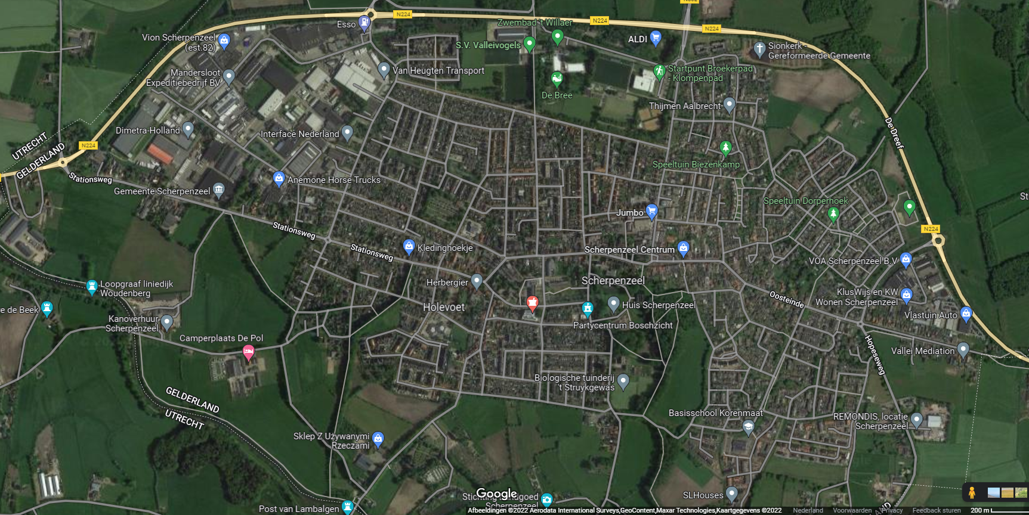
Transportroute vanaf A30
Transportroute vanaf A12
Verlengde Hopeseweg
Dorpsstraat
Koepellaan

Vijverlaan

Dorpsstraat
Holevoetpleinn
Project Vierzinnen
Vijverlaan

