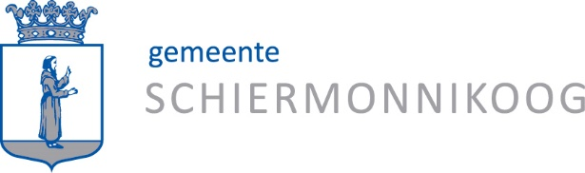

Questionnaire municipal services 2024

Customer satisfaction and expectations: we value your opinion!

The municipality of Schiermonnikoog is developing its services, in order to be able to help you better. Therefore, we would like to hear about your opinions and experiences. What is going well, what could be improved? Thanks to your participation, we shall be able to accommodate your preferences and wishes.
Filling in this questionnaire will take only a few minutes of your time.

What is your relationship with the municipality of Schiermonnikoog?

0 I am an inhabitant
0 I am an entrepreneur
0 I work for an institution or organisation
0 I am a visitor

How old are you?

0 18 years or younger
0 18-30 years
0 31-50 years
0 51-70 years
0 71 years or older

When did your last contact with the municipality take place, to ask a question or to arrange for something? For example, on the phone, at the service desk or using a form on the website?

0 last month
0 between 1 and 6 months ago
0 between 6 and 12 months ago

What was the subject of your contact with the municipality?

Are you content about your contact with the municipality? Please rate your last contact with a note between 1 and 10, by ticking one of the squares below.

1 | 2 | 3 | 4 | 5 | 6 | 7 | 8 | 9 | 10

The following questions are about customer satisfaction. How do you experience the services of the municipality? Please answer the questions below by choosing: I agree, neutral or I disagree.

 | I agree | neutral | I disagree
I feel welcome at the town hall
The opening hours of the town hall are sufficient
The municipality can be reached easily by telephone
The employees of the municipality are customer-friendly
The employees of the municipality think along with me and try to help me further
Questions and requests do not stay unanswered, but are handled quickly
The information of the municipality is clear and understandable
The information on the website is easy to find, comprehensive and understandable
For people who are unable or not willing to choose a digital solution, help is available

What do you expect from us? Please answer the following questions by choosing one of the options: I agree, neutral or I disagree.

 | I agree | neutral | I disagree
I would like to have the possibility to chat or app with the municipality
It is pleasant to have the option of making an online appointment for visiting the town hall
When I call the municipality, it is okay for me that someone calls me back
From the municipality I expect clear procedures, laws, and rules
It is pleasant to have the possibility to make arrangements or requests online
I would like employees of the municipality to help me apply for products and services
Letters, e-mails, and the website are written in straightforward and understandable language
I would like to receive news and updates from the municipality digitally, via the website, socials et cetera
I would like to receive the municipal newsletter in print
The town hall provides opportunities for expositions and meetings by inhabitants, organisations, and associations

Do you have a good idea or a suggestion how we could improve our services?

Thank you very much for answering these questions!

Your answers help us to improve our services. We will share the outcome of this questionnaire with you in the municipal newsletter and on our website. We will handle the results of this questionnaire with care and will not share any personal information with others.

